1. .

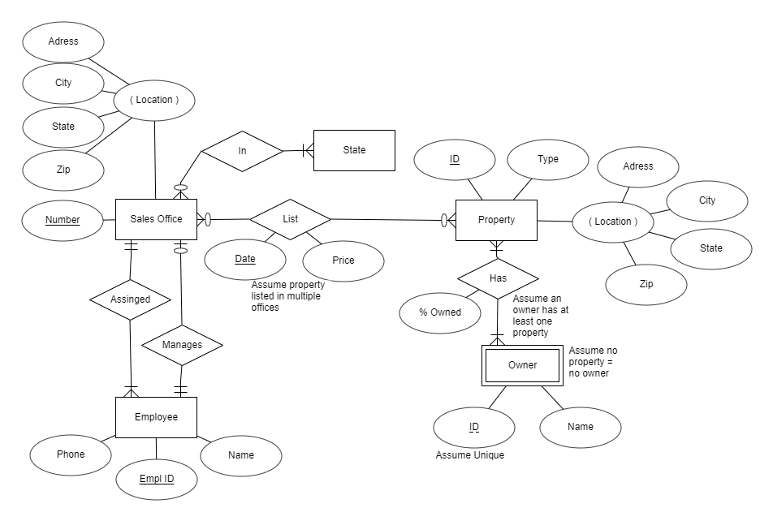

1. .

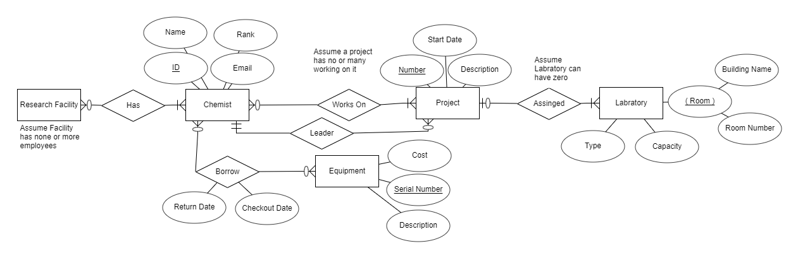

1. Use a DBMS when you need to input or manipulate a lot of data or need security.
   1. DBMS Pro
      1. Synchronous updating.
      2. Efficient accessibility.
      3. File security, recovery.
      4. Records.
      5. Consistency.
   2. DBMS Con
      1. May require secondary storage.
      2. Slow backups, conversion.
2. Use OS when you will have large files or a large number of users.
   1. OS Pro
      1. Less space.
      2. Faster lookup and download.
      3. Cost effective.
   2. OS Con
      1. No file type record.
      2. Clunky to open files.
      3. No security.